# NITTE MEENAKSHI INSTITUTE OF TECHNOLOGY

(AN AUTONOMOUS INSTITUTION)

(AFFILIATED TO VISVESVARAYA TECHNOLOGICAL UNIVERSITY, BELGAUM, APPROVED BY AICTE & GOVT.OF

KARNATAKA)

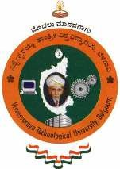

An MINIPROJECT Report

On

“ROBOTIC ARM CONTROL USING HAND GESTURES”

By

Name: USN:

ASHISH BASTOLA 1NT15ME017

*In partial fulfillment of the requirement for the award of the degree of Bachelor of Engineering in Mechanical Engineering during 2018-2019*

Under the Guidance of

Mr. VIKRAM K.V.

Assistant Professor



# Department of Mechanical Engineering

Nitte Meenakshi Institute of Technology, Yelahanka, Bangalore – 560064

2018-2019